**Absentia Season 4: Release date, Cast, Plotline** 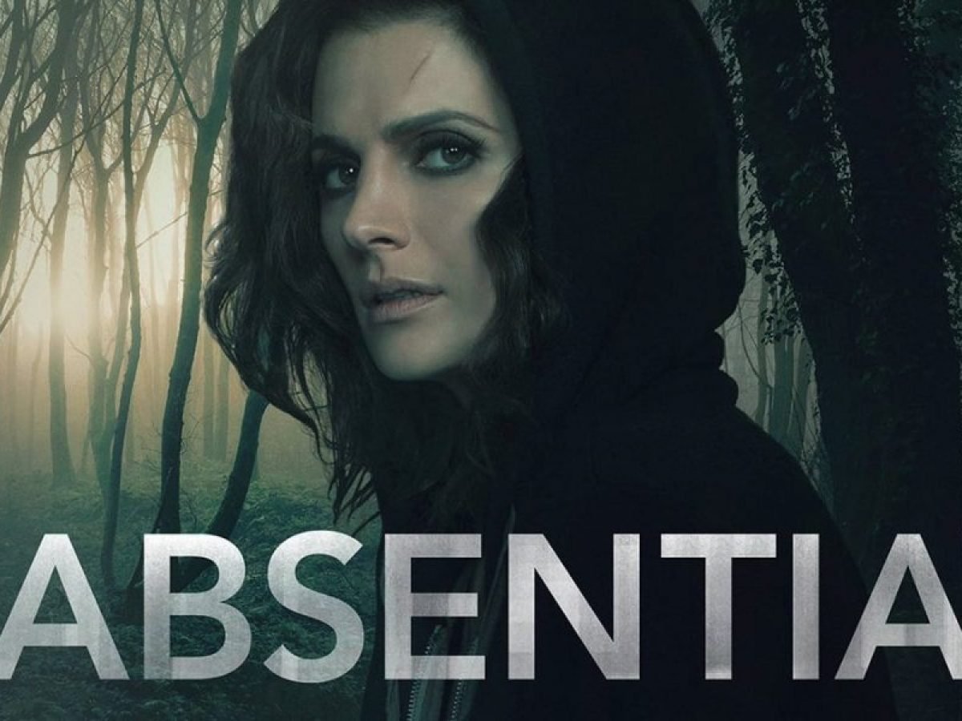

**Absentia**, an American brainteaser drama revolving around mysteries of Emily disappearance. It’s first season was premiered on September 25, 2017. Second season on March 26, 2019, third on July 17, 2020 and now its turn for the fourth season. It was a thrilling series with lots of mysteries to be unrevealed for the fans.

**Absentia season 4: Probable Cast**

Since, *Amazon Prime* Video has not yet renewed the series for *fourth season*. So, we can expect the cast from previous seasons to repeat their roles at least. And there may be some few additional characters though that’s unpredictable as of now who’ll be them. So, let’s recap who were the characters and actors in the previous *seasons* of **Absentia**.

Stana Katic being **Emily Byrne**

Patrick Heusinger being **Nick** Durand

Cara Theobold being **Alice** Durand

Neil Jackson being Jack Byrne

Angel Bonanni being Tommy Gibbs

Bruno Bichir being Dr. Daniel Vega

Paul Freeman being Warren Byrne

Ralph Ineson being Adam Radford

Christopher Colquhoun being Derek Crown

Patrick McAuley being Flynn Durand

Lydia Leonard being Logan Brandt

Richard Brake being Conrad Harlow

Matthew Le Nevez being Cal Isaac

Natasha Little being Julianne Gunnarsen

Hugh Quarshie being Dr. Semo Oduwale

Geoff Bell being Colin Dawkins

Josette Simon being Rowena Kincade

Ross O’Hennessy being Armstrong 

**Absentia Season 4: Plot**

Since **Absentia** has not been yet renewed for the *fourth season*, so it’s open for wide speculation for the storyline which will make up the *season 4*.

*Absentia* started with *season 1* in which *Emily Byrne*, a *FBI* special agent who disappears in the show’s starting while hunting one of the most notorious killer of Boston and thus was declared dead. But six years later, she returns to her family with no memory of what has happened to her in the meantime. While her spouse remarried and her only son barely has any remembrance of her. Later on, she finds herself intrigued as the prime suspect of series of murders.

But at the end of third season she was fortuitously able to unveil Special agent Julianne Gunnarsen’s deception, before escaping everything to live a new life, falsifying the deaths of her former husband and son. She also let her love interest known of her new life and thus we saw **Cal Isaac** seeing a newly **Emily** working at a café at the end of the third season. So, there’re many plots still left to be speculated even though third season ended up, on a good note binding up everything.

**Absentia Season 4: Release date**

Since the creators of the show hasn’t yet renewed, *Absentia* for the season 4 or hasn’t revealed anything about it further, so when the *fourth season* will be telecasted on the viewers screen is completely unpredictable.